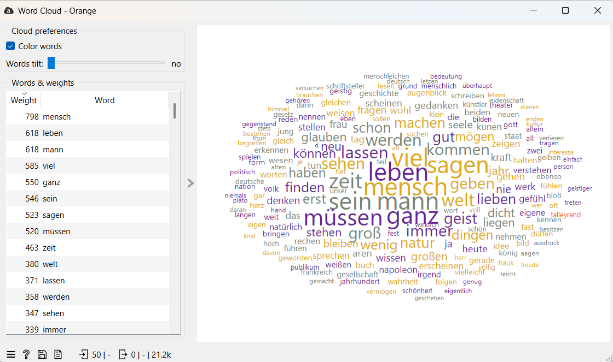
1. Word Cloud. Essay

2. Word Cloud. Essay GPT

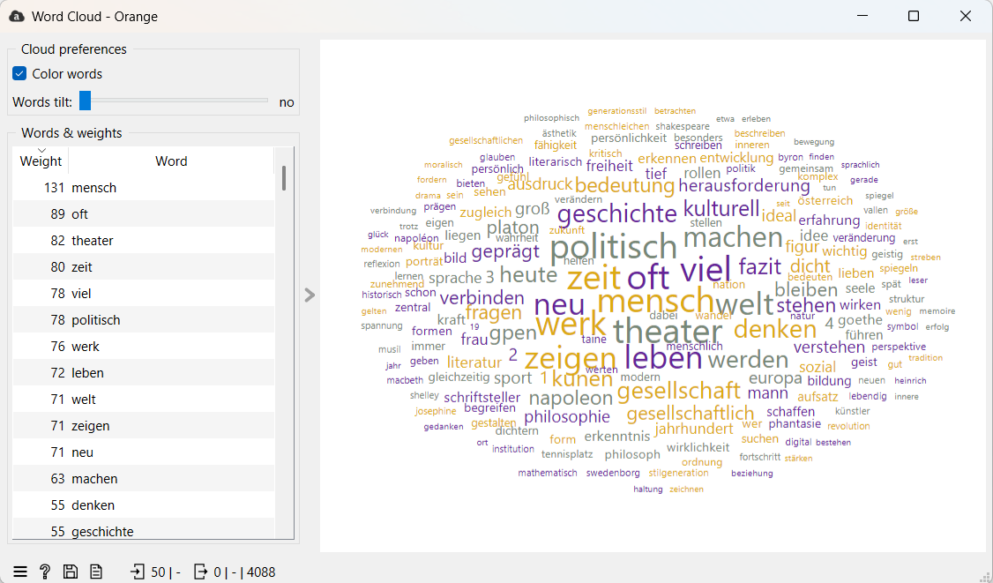
3. Word Cloud. Gedichte

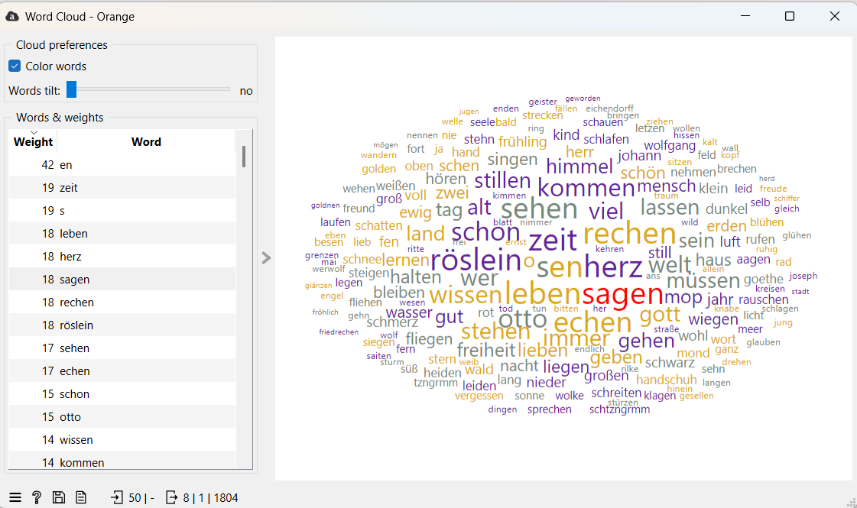

4. Word Cloud. Gedichte GPT

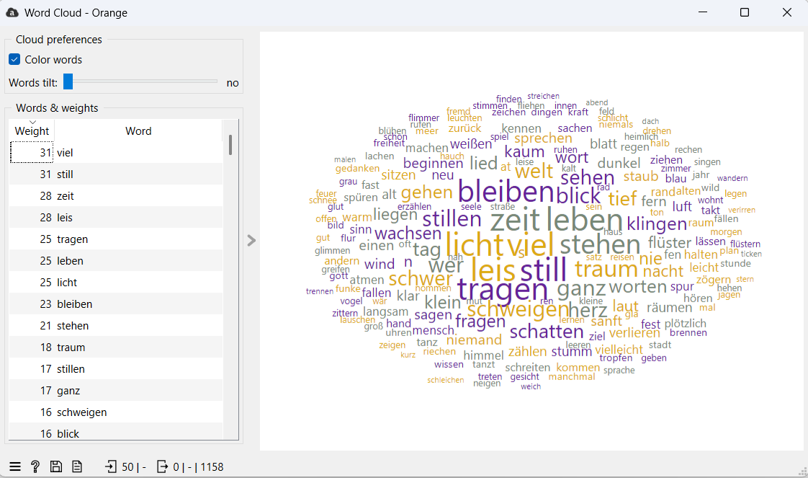

5. Word Cloud. Gedichte. Imitation

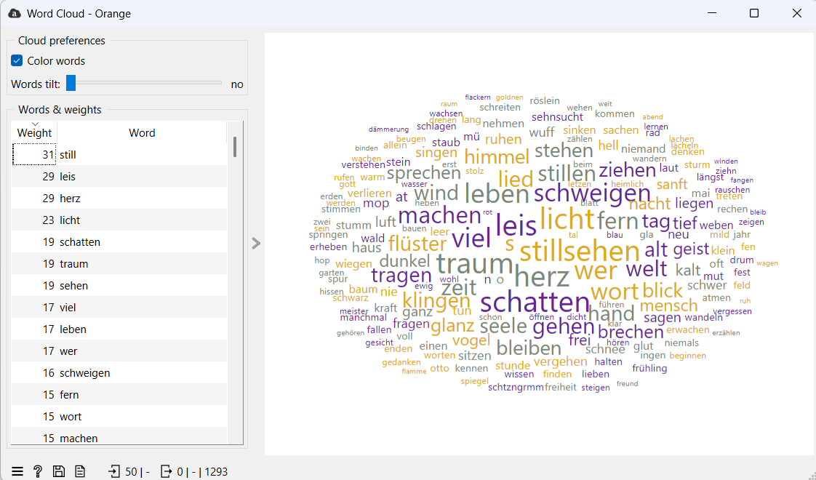

6. Nachrichten

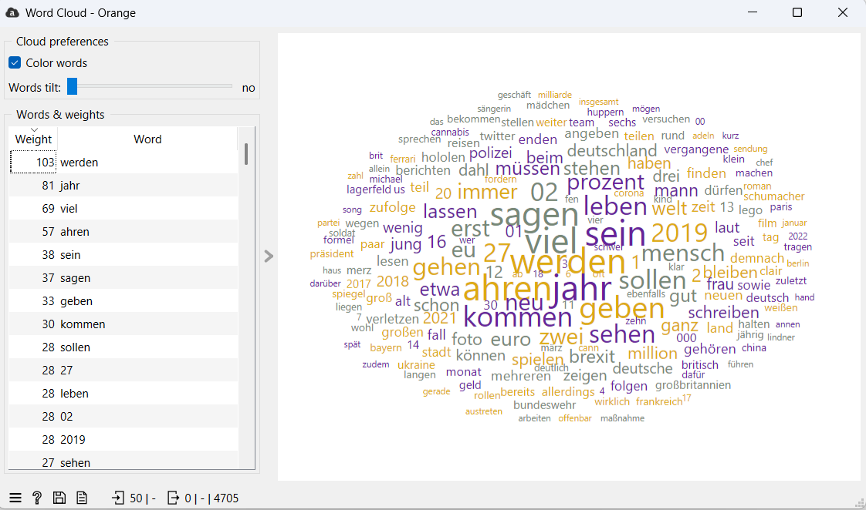

7. Nachrichten. GPT

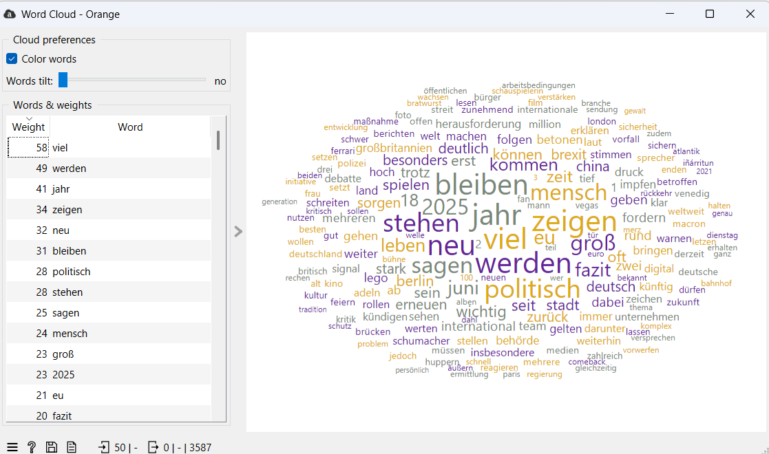

8. Posts. LinkedIN.

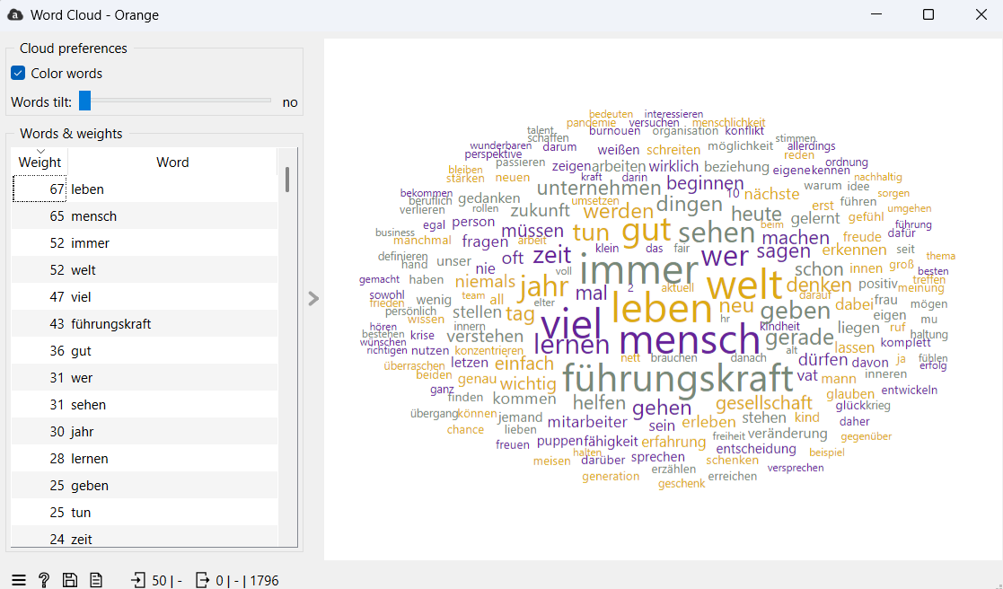

9. Posts. LinkedIN. GPT.

